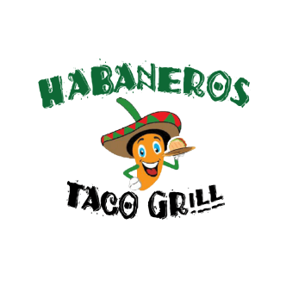

TEACHERS WE APPRECIATE YOUR GUIDANCE AND MENTORSHIP

DURING THE APPRECIATION WEEK

FROM MAY 5 TO MAY 9, 2025

SHOW YOUR SCHOOL EMPLOYEE ID FOR A 10% OFF IN ANY ORDER

|  |
| --- |
| HABANEROS TACO GRILL 4  7455 S EASTERN AVE  LAS VEGAS NV, 89123 |

|  |
| --- |
| *HABANEROS TACO GRILL 5*  *171 W. CENTENIAL PKWY*  *NORTH LAS VEGAS, 89084* |