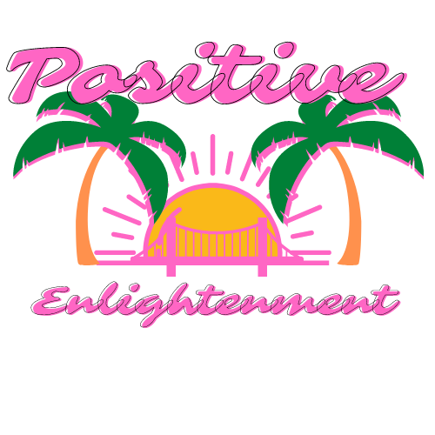

**Dr. Ashley Key**

**We all need help every now and then. All sessions are**

**confidential. Insurance is not accepted but prices are**

**extremely reasonable. Sessions are either virtual**

**or in person.**

**Contact information:**

[**positiveecs.com**](positiveecs.com#positiveecs.com)

[**https://www.psychologytoday.com/profile/1123146**](https://www.psychologytoday.com/profile/1123146#https://www.psychologytoday.com/profile/1123146%20)

**(702) 934-1155**

**Contact Dr. Ashley Key for more information**

**Show your CCSD I.D. and get your first 30 minute session for free with this link:**

**<https://tinyurl.com/54474tvz>**

**Mental Health Consulting**

**Educator Stress and Emotional Support**

**Career Coaching**

**Life Coaching**

**Family Dynamics**

**Relationship Restoration**

**Educational Coaching**

**Dealing with Toxic Jobs and people**

**Rebuilding self-esteem after the loss of a relationship**

**Political Stress**

**Anger/Anxiety prevention**

**Finding your purpose**

**And much more……**

**Positive Enlightenment is a mental health consultation company that offers a variety of services such as:**

Positive Enlightenment Consultation Services LLC