Alan Lasker Randy Kono
702-737-3276 702-304-2110

horacemann.com
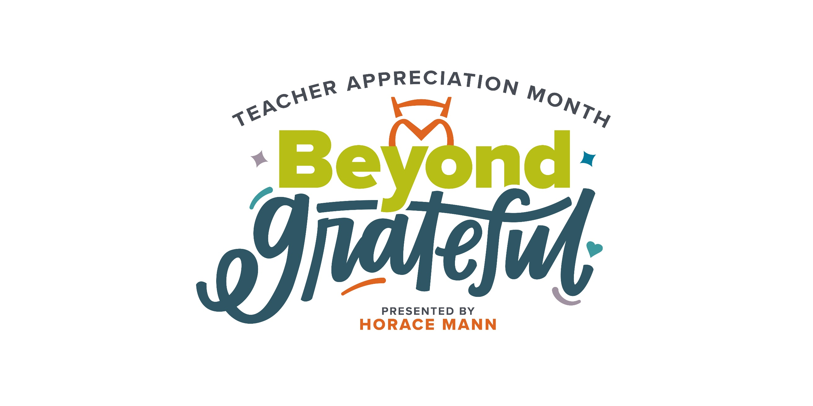
Thank you for ALL you do
Teacher Appreciation 2025 | $2,500 Gas Card Giveaway
This Teacher Appreciation Week, we’d like to thank Clark County School District educators for all you do with a giveaway!
What: $50 gas card to 50 lucky teachers
Deadline to enter: Now through Sunday, May 11, 2025
Drawing date: May 12, 2025
Enter today: https://woobox.com/sj8wpb
Horace Mann is the largest financial services company focused on providing America’s educators and school employees with affordable auto, home and life insurance as well as retirement solutions. Founded by educators for educators, we understand firsthand the challenges educators face each and every day – that is why we have designed our products and services with educators and their families in mind.

 | Scan here  to enter!


Rich Israel Joshua Lamers Mark Goecke
702-895-9226 702-310-6869 702-895-9230
No purchase or policy quote necessary to enter or win. Void where prohibited. Must be at least 18 years old at time of entry. Open only to residents in the state of Nevada.
This promotion is not affiliated with, sponsored by, or conducted by Horace Mann. Promotion is sponsored and conducted solely by the agent named above, who is an independent contractor and not an employee of Horace Mann. Contact the agent for any further details and restrictions.
AM-C04645 (4-25)

